LAB # 06
DEADLOCK IN CONCURRENCY
OBJECT:
Implementing multiple thread blocked resources with help of lock and deadlock conditions.
LAB TASK:
Create three threads by implementing thread synchronization block through 3 locks. (Hint: Apply un-sequenced lock to analyze deadlock and solve it through provided solution):
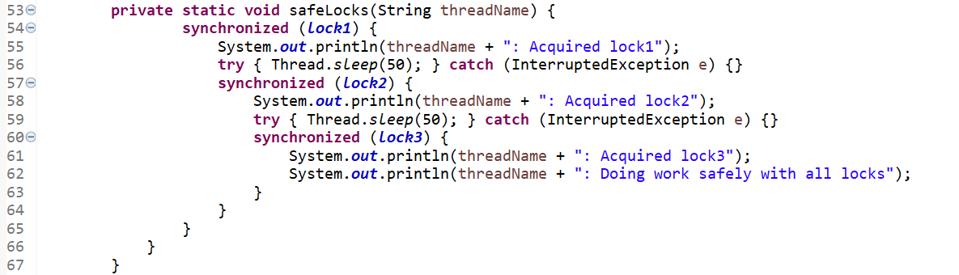
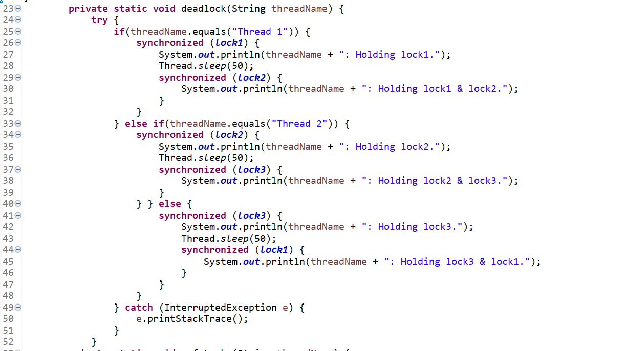
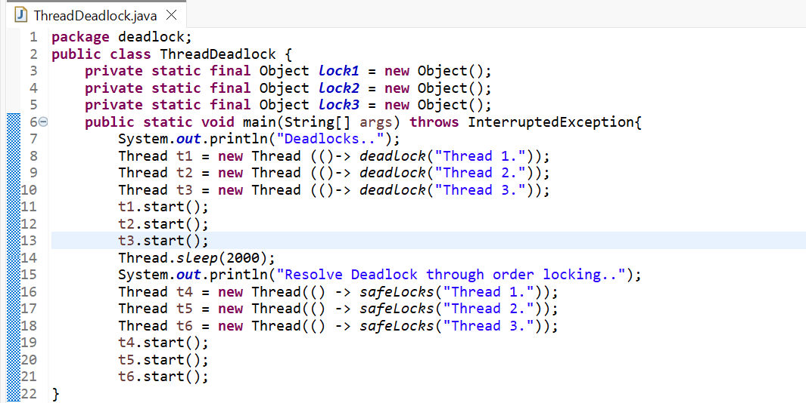
CODE:
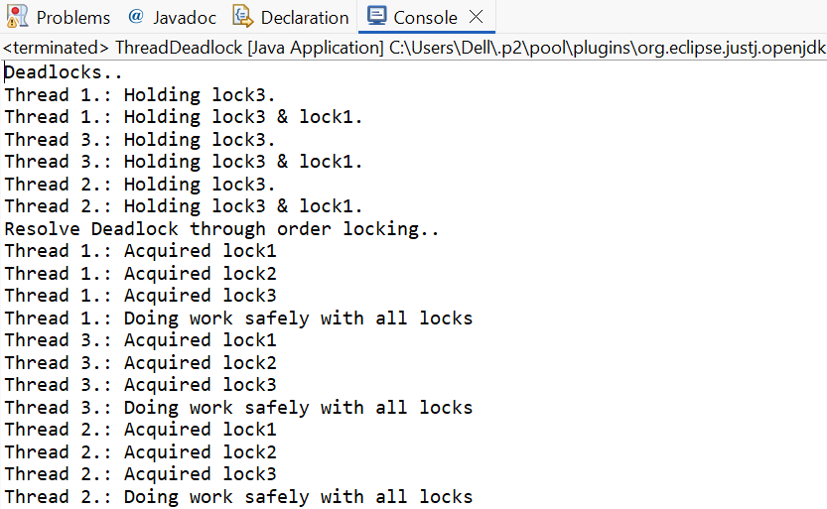
OUTPUT:

